Spanners in Graph of Bounded degree
Leizhen Cai and Mark keil
Networks,Vol.24(1994)233-249
- Abstract
- Introduction
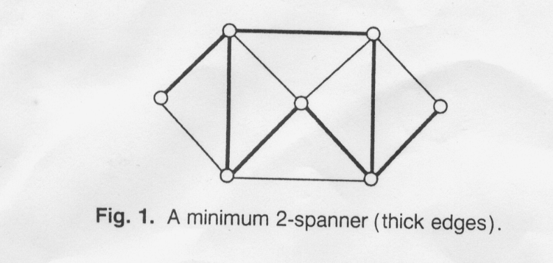
Theorem 1.1. A minimum 2-spanner of any degree-4
- graph can be found in linear time.
- Theorem 1.2. For any fixed t 2, MINIMUM t-SPANNER is NP-complete for degree 9 graphs.

Definition
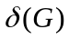 and 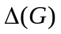 denote the minimum and maximum degree of G
2.THE TRIANGULAR PARTION OF A GRAPH
deinition :
- Let G=(V,E) be a graph. Let 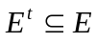 be the set of edges that are contained in some triangles of G and let 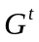 =(V , 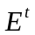') Then, G - is a triangle-free graph, i.e., a graph with no triangle, which will be referred to as the triangle-free component of G.
- Define a binary relation “~” on as follows: For any two edges and 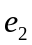 in ( not necessarily distinct), ~ iff there is a triangle in
G that contains both edges. Clearly, " ~" is reflexive and symmetric. Then, the transitive closure "~*" of "~" defines a partition of . Each element in the partition corresponds to a partial subgraph of G, and such a partial subgraph is called a triangular-component ofG. Obviously, every graph can be uniquely edge-partitioned into a triangle-free component and triangular-components; such an edge partition is called the triangular partition of G and denoted by II(G) (see Fig. 2 for an example).

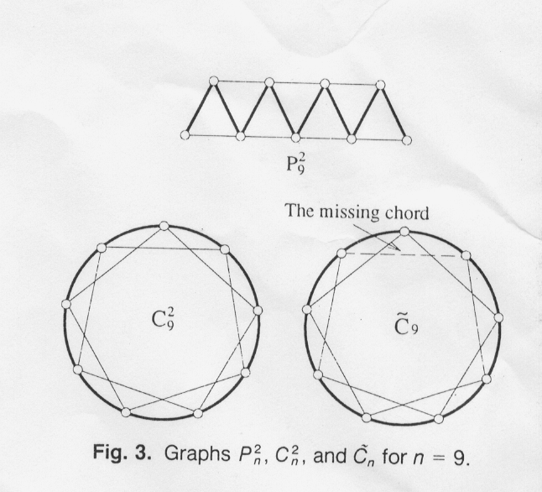
- The edge-triangle graph of G, denoted ET(G), is the graph whose vertices are edges of G and where two vertices are adjacent iff their corresponding edges are contained in a triangle of G (see Fig.2 for an example). The 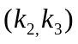-intersection graph* of G , denoted 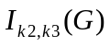, is the graph whose vertices are triangles of G and where two vertices are adjacent iff their corresponding triangles share an edge of G (see Fig. 2 for an example).
- 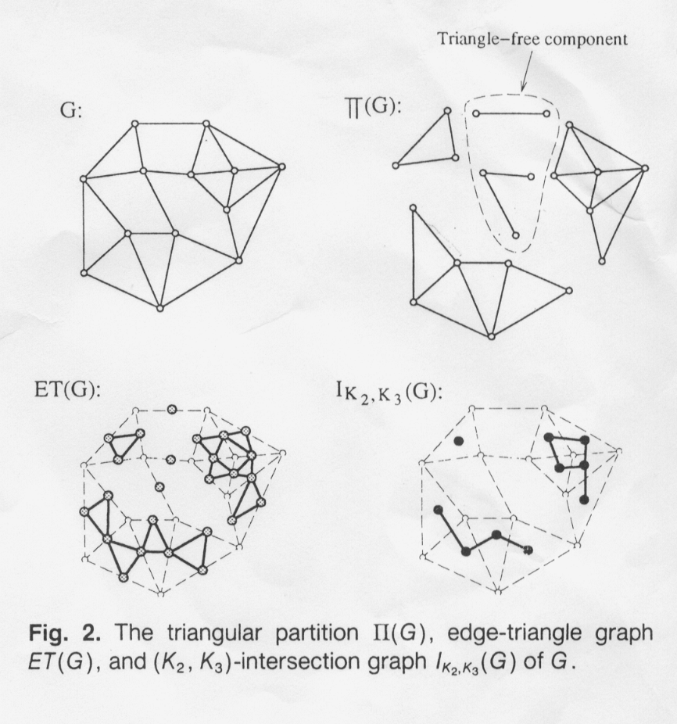 .
- Theorem 2.1. For any graph G =(V.E), the following three statements are equivalent:
- 1. H is a triangular-component of G
- 2. ET(H) is a nontrivial connected component of ET(G)
- 3. 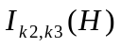 is a connected component of every edge of H belongs to some triangles of H.
- Theorem 2.2. A spanning subgraph S of G is a 2-spanner iff for every subgraph H II(G), S H is a 2-spanner of H.
- Corollary 2.3. A spanning subgraph S of G is a minimum 2-spanner iff for every subgraph H II(G), S H is a minimum 2-spanner of H.
Algorithm of compute ET(G)
E' =  {E' is the edge set o{ ET(G)}
- for each edge xy E do

Let N =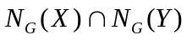;
For every edge vertex v N do
Add edges {xy,xv} and {xy,yv} to the edge set E’ of ET(G);
Endfor
endfor
- Theorem 2.4. The triangular partition of a graph can be obtained in time O(|E|).
3. A LINEAR ALGORITHM FOR DEGREE-4 GRAPHS
algorithm
THEOREM 3.1 any triangle-component of a degree-4 graph is isomorphic to either 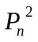 for some n 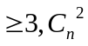 for some 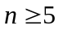 , 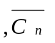 for some n >=5,or one of the seven graphs in fig 4.
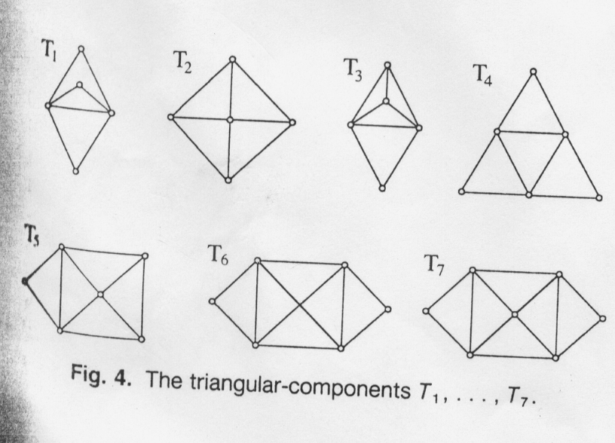
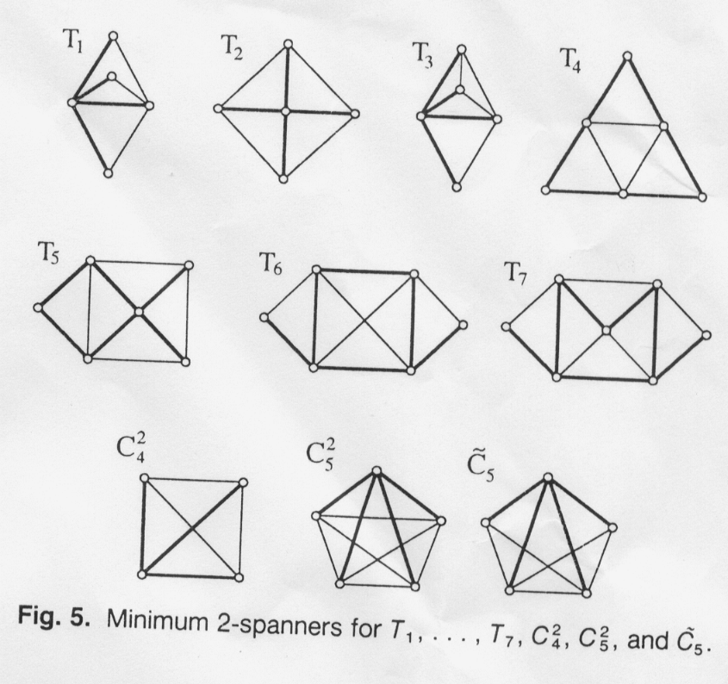

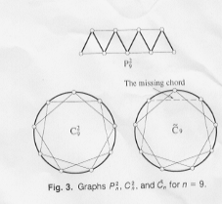
- NP-COMPLETENESS FOR DEGREE-9 GRAPHS

Example

Created by : Shine-Hyue Wu
Date : Jul 19, 2001

